Name : MUHAMMAD MUBASHAR ALI

Student ID : BSIET02213012

Subject : Object Oriented Programming

Lab : 03

Example # 01

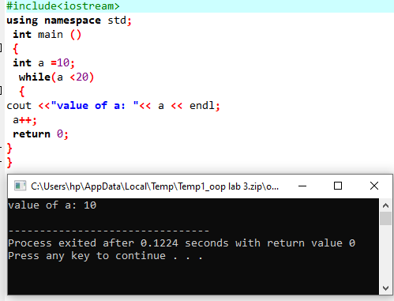

Example # 02

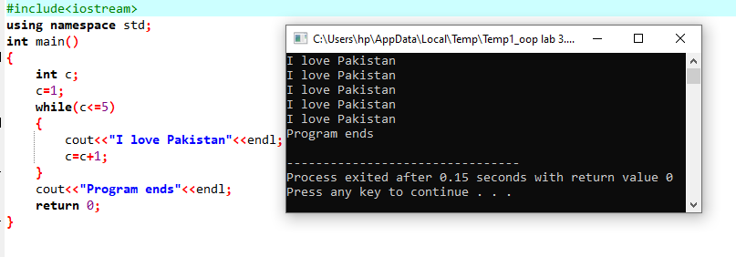

Example # 03

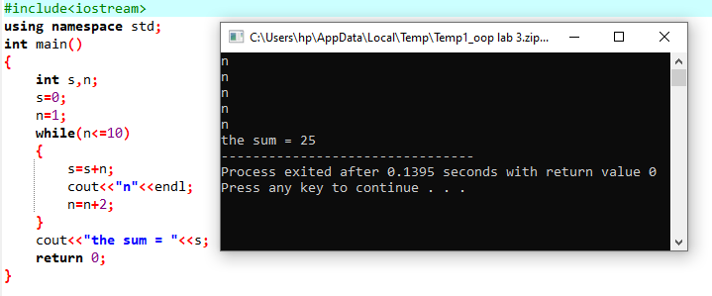

Example # 04

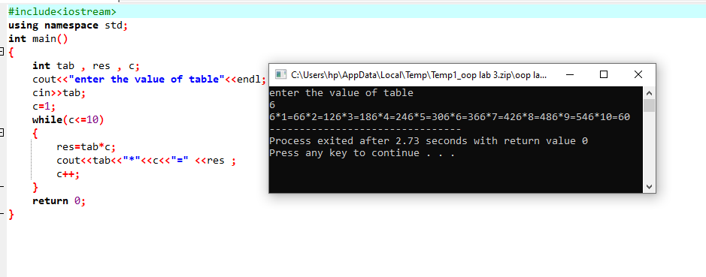

Example # 05

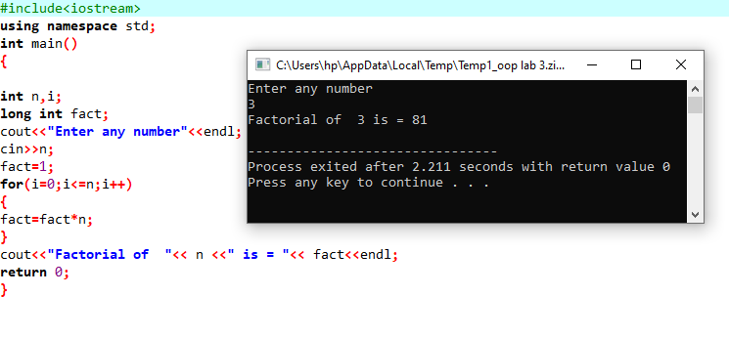

Example # 06

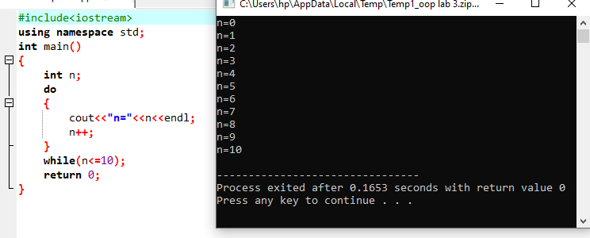

Example # 07

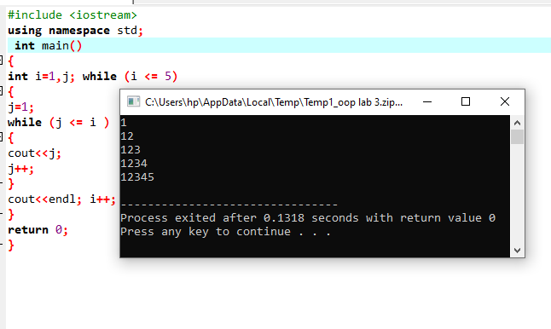

Example # 08

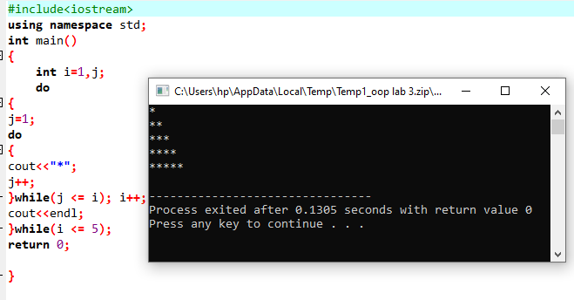

Review Questions

Question # 01

Write a C++ program to find the summation of the following series (using while statement) S=1+ 4 + 9+ 16+………+ (n*n)?

Answer

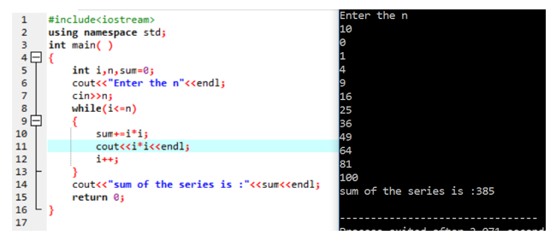

Question # 02

Write a C++ program to print all numbers (that are multiple of 3) from 1 to 100 every 6 numbers on a line.?

Answer

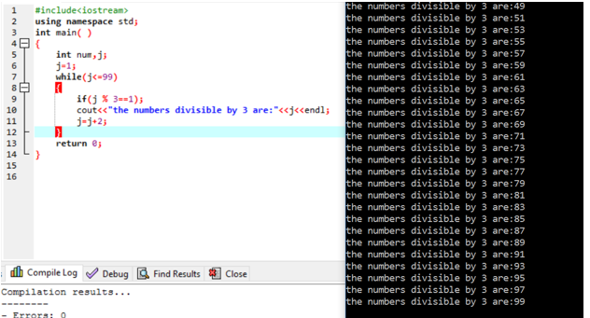

Question # 03

Write a C++ program to find the summation of even digits for any read number from the keyboard (the number could be of any length).?

Answer

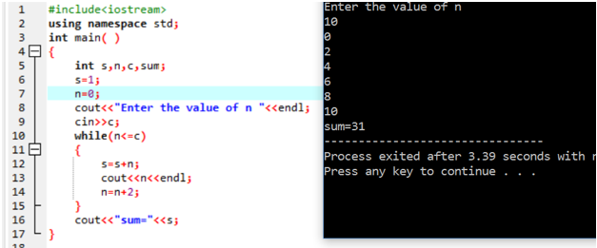

Question # 04

Write a program that computes the sum of the following series using do while loop 1+1/3 +1/5+ 1/7 + + 1/99?

Answer

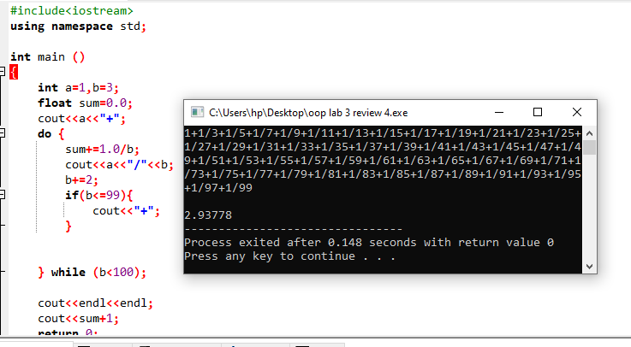

Question # 05

Write a program that displays the output as given under using the nested while loop

|  |  |
| --- | --- |
| 1 |  |
| 1 | 4 |
| 1 | 4 9 |
| 1 | 4 9 16 |
| 1 | 4 9 1625 |

Answer

